Project -151
Title:Demonstrate how to create a database in MongoDB
Source code: use myDatabase
Output:
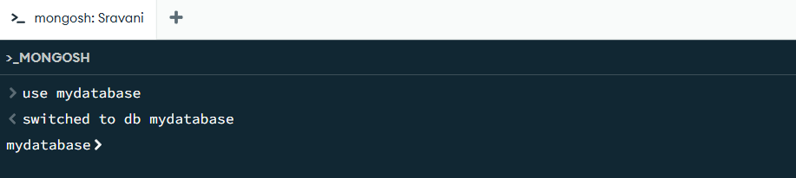

Project -152
Title:Demonstrate how to create a collection in MongoDB
Source code: db.createCollection("students")
Output:
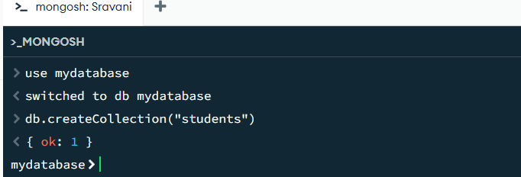

Project-153
Title:Demonstrate how to insert a document into a MongoDB collection
Source code: db.students.insertOne({ name: "Sravani", course: "Degree", age: 19 })
Output:
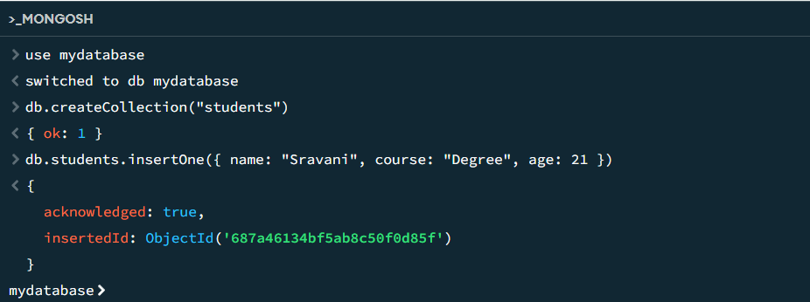

Project-154
Title:Demonstrate how to find documents in a MongoDB collection
Source code: db.students.find()
Output:
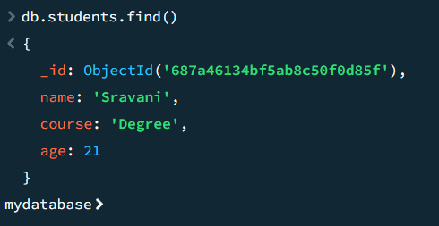

Project-155
Title:Demonstrate how to update a document in MongoDB
Source code: db.students.updateOne(
{ name: "Sravani" },
{ $set: { age: 21 } } )
Output:
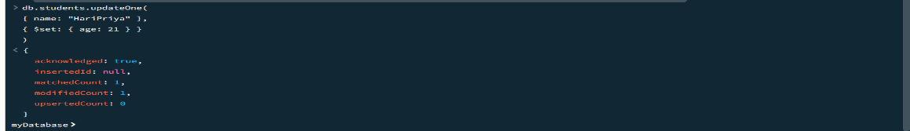

Project-156
Title:Demonstrate how to delete a document in MongoDB
Source code: db.students.deleteOne({ name: "Sravani" })
Output:
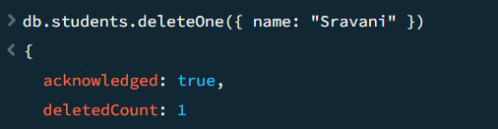

Project-157
Title: Demonstrate how to insert multiple documents using insertMany()
Source code:db.students.insertMany([
{ name: "Nani", course: "Degree", age: 19 },
{ name: "Sonu", course: "B.Tech", age: 20 },
{ name: "Rahul", course: "BBA", age: 21 } ]
)
Output:
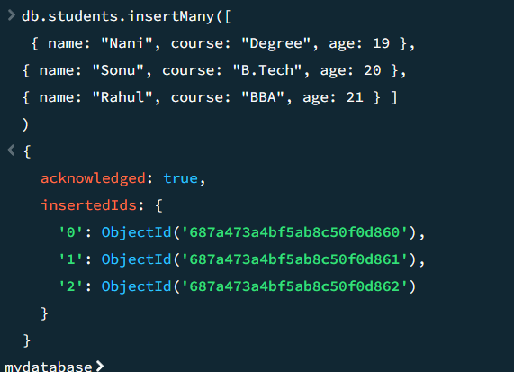

Project -158
Title:Demonstrate how to find documents using a filter in MongoDB
Source code: db.students.find({ course: "Degree" })
Output:

Project-159
Title:Demonstrate how to retrieve all documents using find()
Source code: db.students.find()

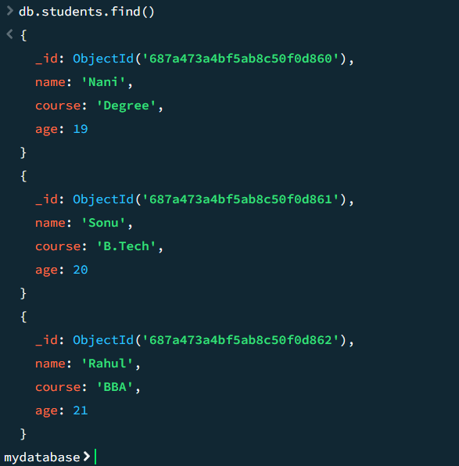

Project-160
Title:Demonstrate how to update multiple documents using updateMany()
Source code: db.students.updateMany(
{ course: "Degree" },
{ $set: { status: "active" } }
)
Output:
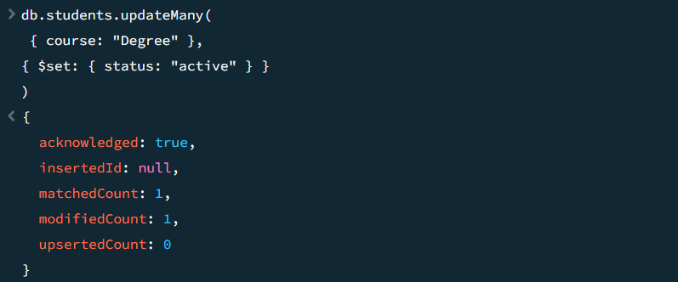

Project-161
Title:Demonstrate how to delete multiple documents using deleteMany()
Source code: db.students.deleteMany({ course: "BBA" })
Output:
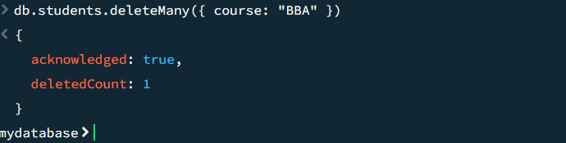

Project-162
Title:Demonstrate how to use the $eq (equal) operator in MongoDB
Source code: db.students.find({ age: { $eq: 20 } })
Output:
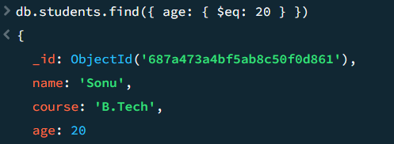

Project-163
Title:Demonstrate how to use the $ne (not equal) operator in MongoDB
Source code: db.students.find({ course: { $ne: "Degree" } })
Output:
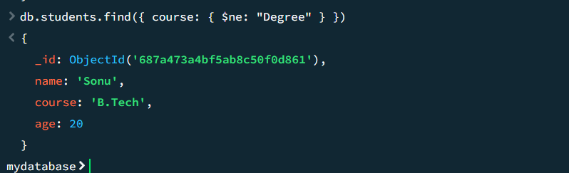

Project-164
Title:Demonstrate how to use the $gt (greater than) operator in MongoDB
Source code: db.students.find({ age: { $gt: 19} })
Output:
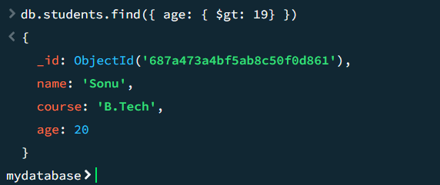

Project-165
Title:Demonstrate how to use the $gte (greater than or equal to) operator in MongoDB
Source code:db.students.find({ age: { $gte: 20 } })
Output:
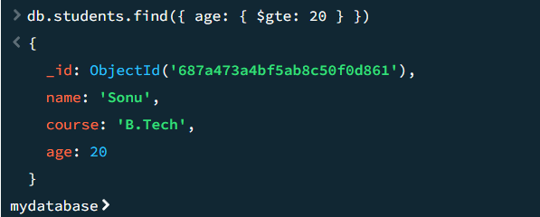

Project-166
Title:Demonstrate how to use the $lt (less than) operator in MongoDB
Source code: db.students.find({ age: { $lt: 22 } })
Output:
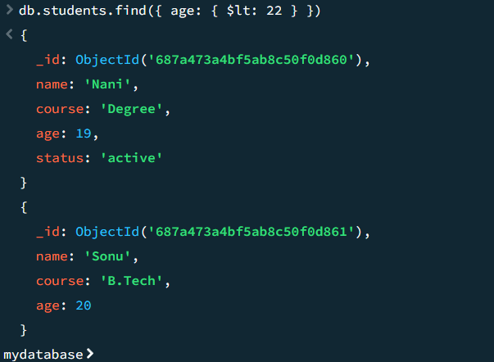

Project-167
Title:Demonstrate how to use the $lte (less than or equal to) operator in MongoDB
Source code: db.students.find({ age: { $lte: 21 } })
Output:
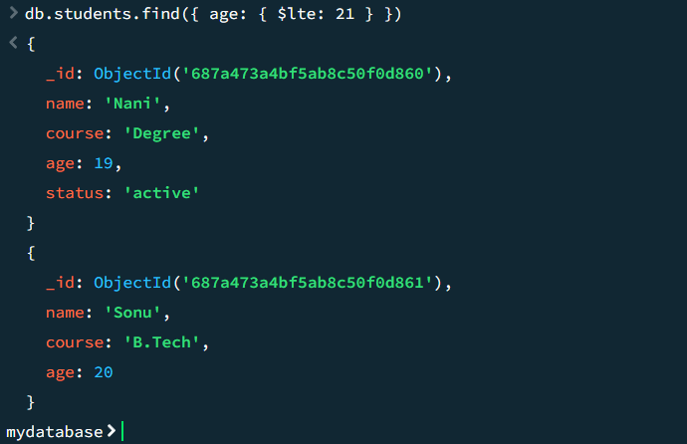

Project-168
Title:Demonstrate how to use the $in operator in MongoDB
Source code: db.students.find({ course: { $in: ["Degree", "B.Tech"] } })
Output:
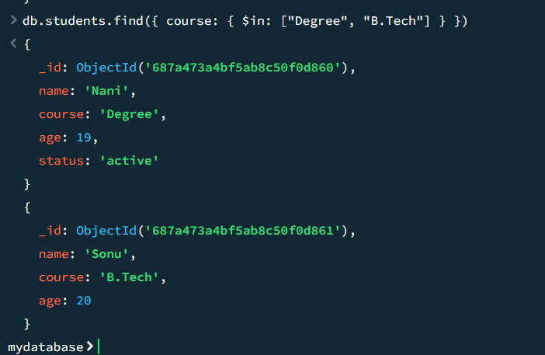

Project-169
Title:Demonstrate how to use the $and logical operator in MongoDB
Source code: db.students.find(
{ $and: [ { age: { $gte: 20 } },
{ course: "B.Tech" } ] }
)
Output:
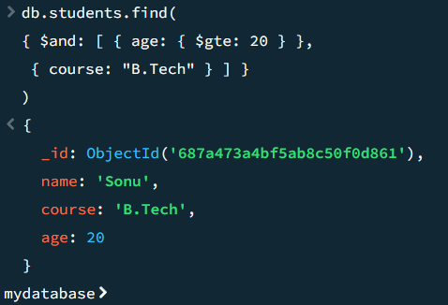

Project-170
Title:Demonstrate how to use the $or logical operator in MongoDB
Source code: db.students.find({ $or: [ { course: "Degree" }, { course: "B.Tech" } ] })
Output:
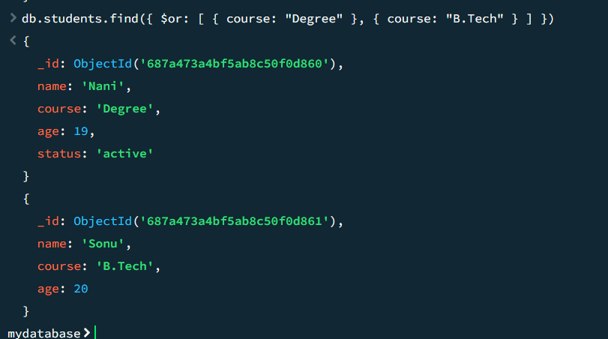

Project-171
Title:Demonstrate how to use the $not logical operator in MongoDB
Source code: db.students.find({ age: { $not: { $lt: 19 } } })
Output:
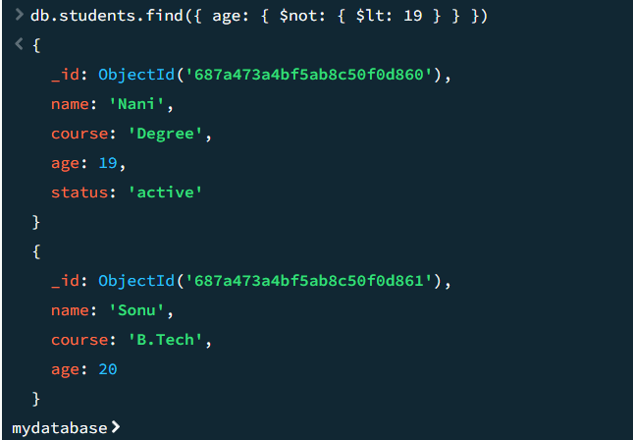

Project-172
Title:Demonstrate how to create a new schema with bsonType and required using db.createCollection() in MongoDB
Source code:
db.createCollection("users", {
validator: {
$jsonSchema: {
bsonType: "object",
required: ["name", "email", "age"],
properties: {
name: {
bsonType: "string",
description: "must be a string and is required"
},
email: {
bsonType: "string",
pattern: "^.+@.+$",
description: "must be a valid email and is required" },
age: {
bsonType: "int",
minimum: 18,
maximum: 100,
description: "must be an integer between 18 and 100"
},
isActive: {
bsonType: "bool",
description: "must be a boolean"
},
createdAt: {
bsonType: "date",
description: "must be a date"
}
}
}
}
});
Output:
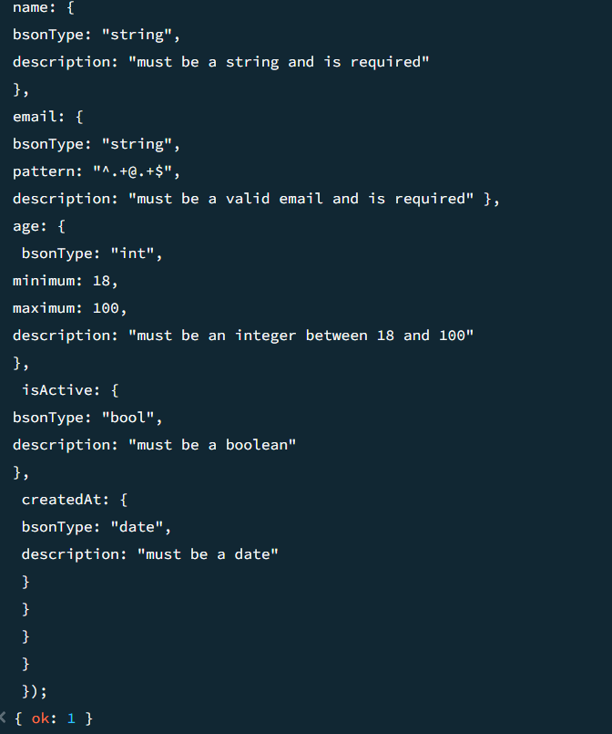

Project-173
Title:Demonstrate how to apply or modify schema validation on an existing MongoDB collection using collMod
Source code:
db.runCommand({
collMod: "users",
validator: {
$jsonSchema: {
bsonType: "object",
required: ["name", "email"],
properties: {
name: { bsonType: "string" },
email: { bsonType: "string", pattern: "^.+@.+$" }
}
}
},
validationLevel: "strict",
validationAction: "error"
});
Validation Test Cases
✔ Valid Insert:
db.users.insertOne({
name: "Sai Parla",
email: "saiparla070@gmail.com",
age: 22,
isActive: true,
createdAt: new Date()
});
❌ Invalid Insert (fails validation):
db.users.insertOne({
name: "Sai",
email: "not-an-email",
age: "twenty"
});
Output:
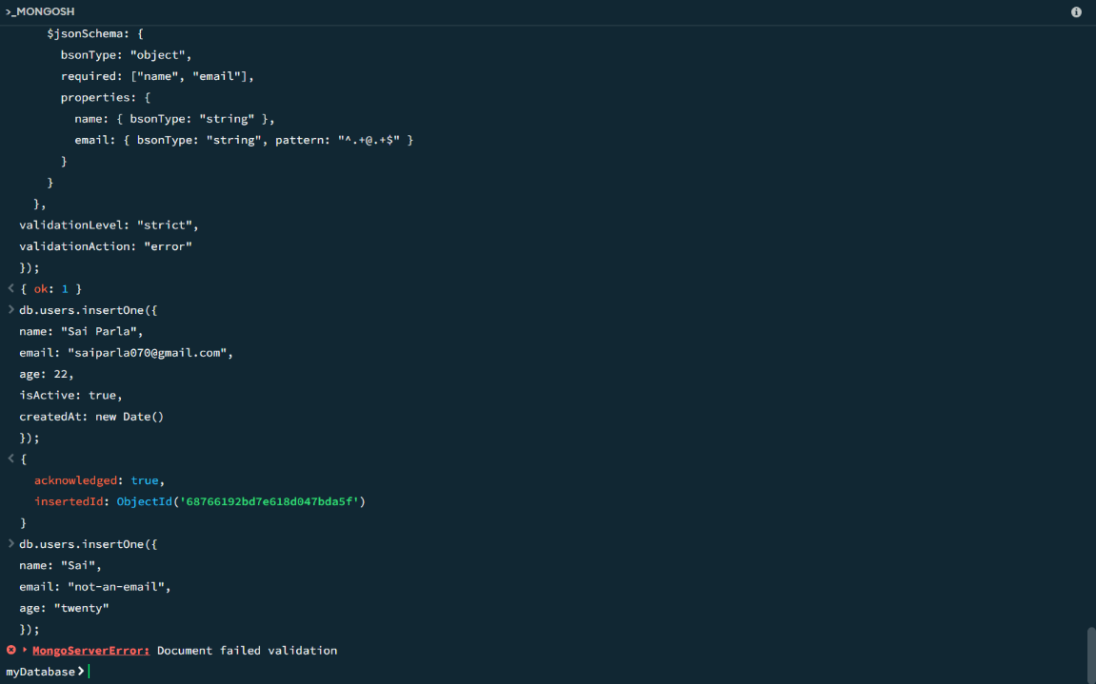

Project-174
Title:Demonstrate the use of $currentDate to update a field with the current date
Source code:db.users.updateOne( { name: "Sravani" }, { $currentDate: { lastModified: true } } );
Output:
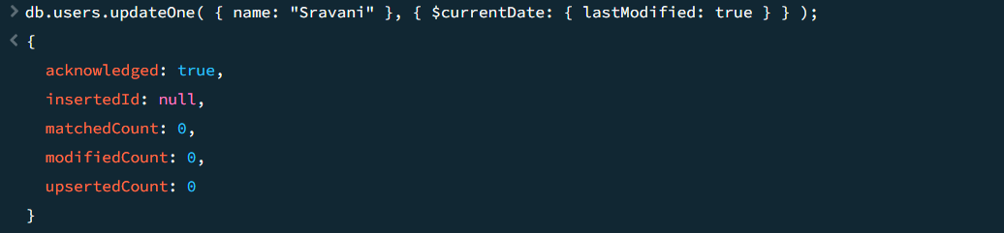

Project-175
Title: Demonstrate the use of $inc to increment a field
Source code:db.users.updateOne( { name: "HariPriya" }, { $inc: { age: 1 } } );
Output:
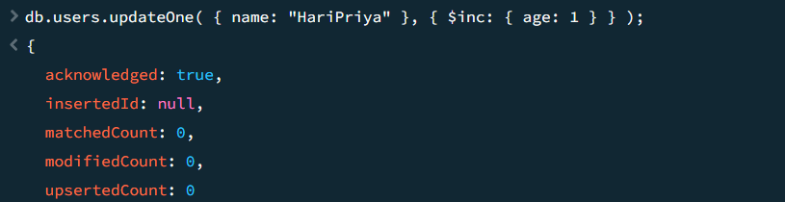

Project-176
Title:Demonstrate the use of $rename to rename a field
Source code:db.users.updateOne( { name: "Sravani" }, { $rename: { "email": "emailAddress" } } );
Output:
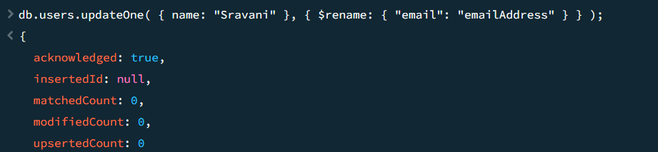

Project-177
Title:Demonstrate the use of $set to set a new value to a field
Source code:
db.users.updateOne( { name: "Sravani" }, { $set: { country: "India" } } );
Output:
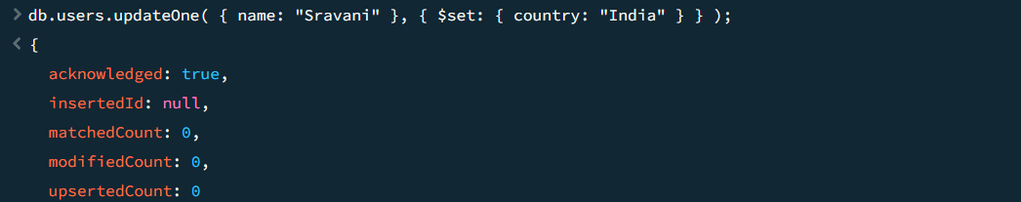

Project-178
Title:Demonstrate the use of $unset to remove a field
Source code:
db.users.updateOne( { name: "Sravani" }, { $unset: { status: "" } } );
Output:
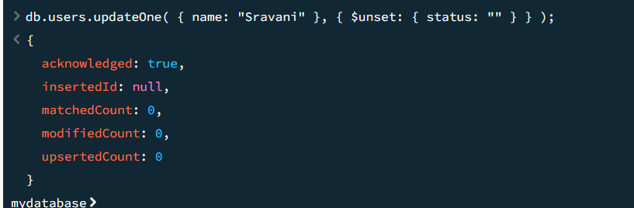

Project-179
Title:Demonstrate the use of $addToSet to add a unique value to an array
Source code:
db.developers.updateOne( { name: "Sravani" }, { $addToSet: { skills: "JavaScript" } } );
Output:
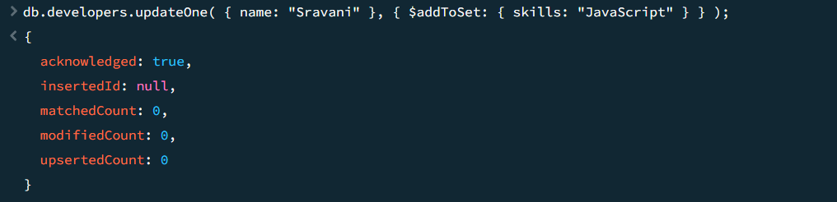

Project-180
Title:Demonstrate the use of $pop to remove the last element of an array
Source code:
db.developers.updateOne( { name: "Sravani" }, { $pop: { skills: 1 } } );
Output:
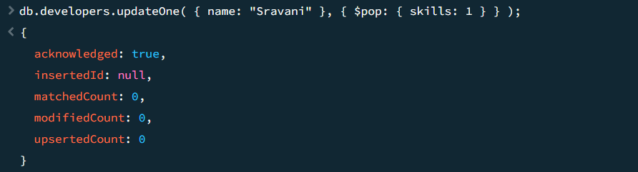

Project-181
Title:Demonstrate the use of $pull to remove a matching value from an array
Source code:
db.developers.updateOne( { name: "Sravani" }, { $pull: { skills: "CSS" } } );
Output:
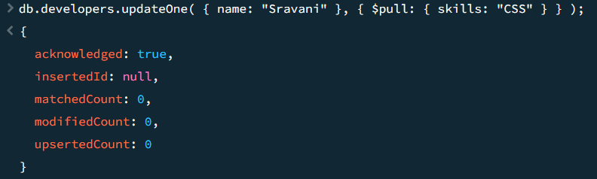

Project-182
Title:Demonstrate the use of $push to add a value to the end of an array
Source code:
db.developers.updateOne( { name: "Sravani" }, { $push: { skills: "MongoDB" } } );
Output:
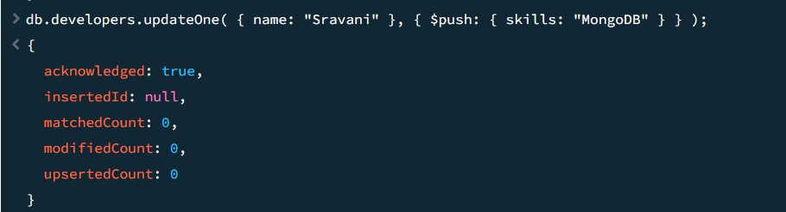

Project-183
Demonstrate the use of upsert in MongoDB to update or insert a document
Source code:
db.users.updateOne( { name: "Dilli" }, { $set: { age: 25, city: "Hyderabad" } }, { upsert: true } );
✅ If a user named "Dilli" exists, the document is updated.
✅ If "Dilli" doesn't exist, a new document is created.
Output:

Project-184
Title:Demonstrate the use of `$group` in MongoDB aggregation
Source code:
db.orders.aggregate([
{
$group: {
_id: "$customerId",
totalAmount: { $sum: "$amount" }
}
}
]);
Output:
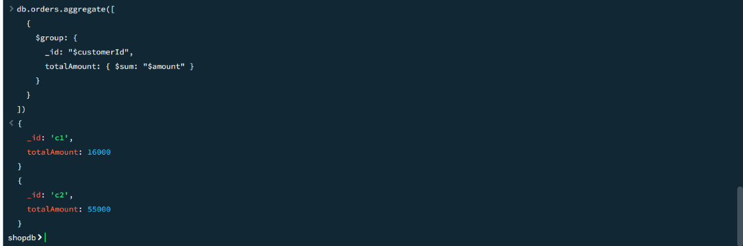

Project-185
Title:Demonstrate the use of `$limit` in MongoDB aggregation
Source code:
db.orders.aggregate([ { $limit: 5 } ]);
Output:
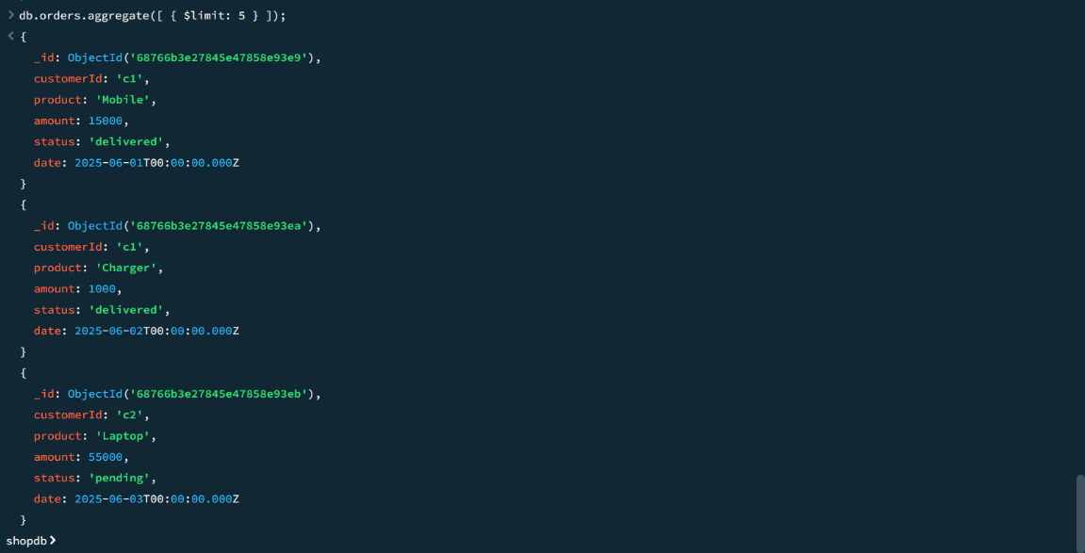

Project-186
Title:Demonstrate the use of `$project` in MongoDB aggregation
Source code:
db.orders.aggregate([ { $project: { _id: 0, customerId: 1, amount: 1 } } ]);
Output:
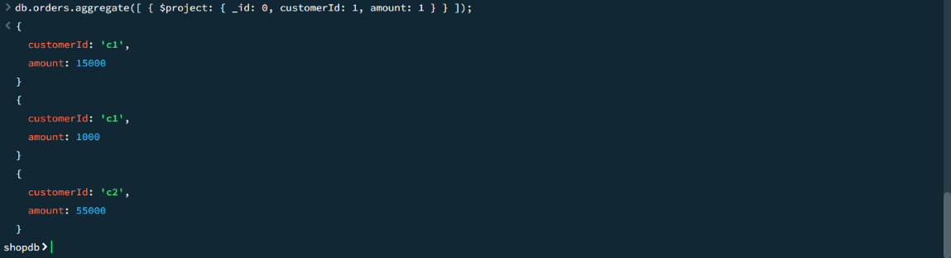

Project-187
Title:Demonstrate the use of `$sort` in MongoDB aggregation
Source code:
db.orders.aggregate([ { $sort: { amount: -1 } } ]);
Output:
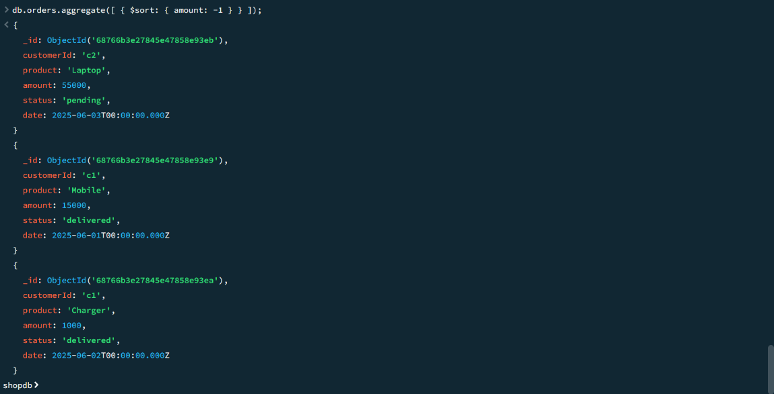

Project-188
Title:Demonstrate the use of `$match` in MongoDB aggregation
Source code:
db.orders.aggregate([ { $match: { status: "delivered" } } ]);
Output:
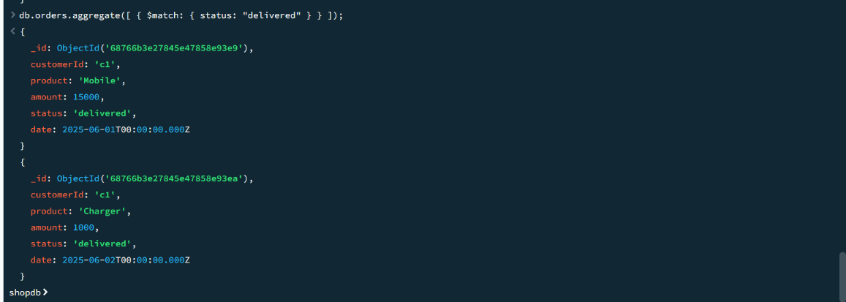

Project-189
Title:Demonstrate the use of `$skip` in MongoDB aggregation
Source code:
db.orders.aggregate([ { $skip: 1 } ]);
Output:
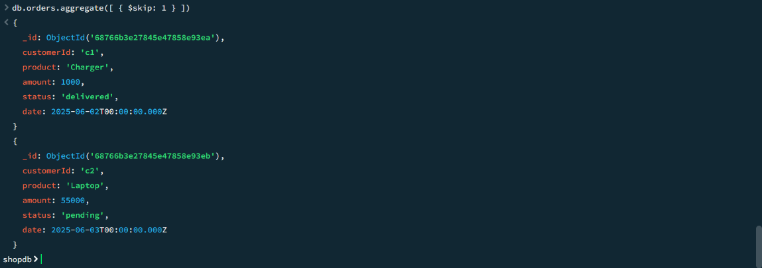

Project-190
Title:Demonstrate the use of `$count` in MongoDB aggregation
Source code:
db.orders.aggregate([ { $match: { status: "delivered" } }, { $count: "totalDelivered" } ]);
Output:
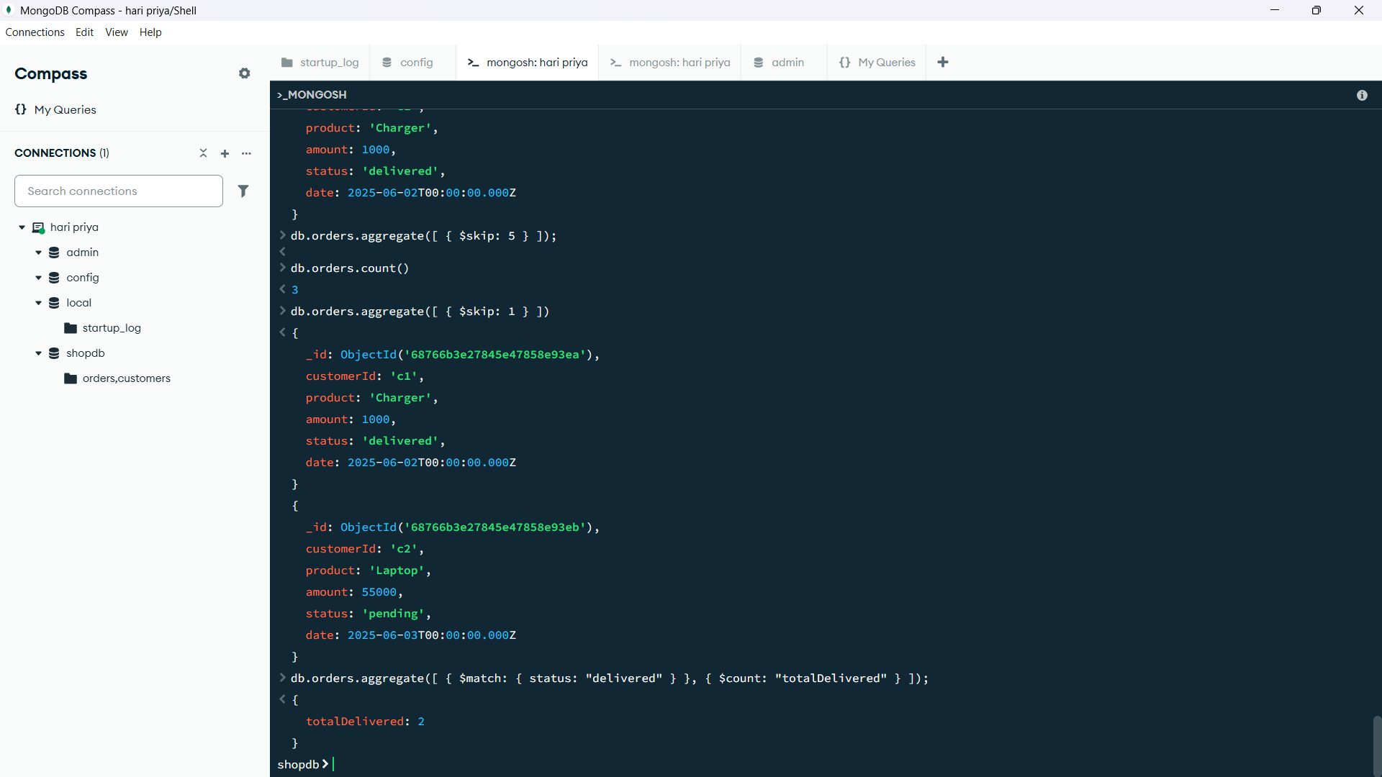

Project-191
Title:Demonstrate the use of `$lookup` in MongoDB aggregation
Source code:
db.orders.aggregate([ { $lookup: { from: "customers", localField: "customerId", foreignField: "_id", as: "customerDetails" } } ]);
Output:
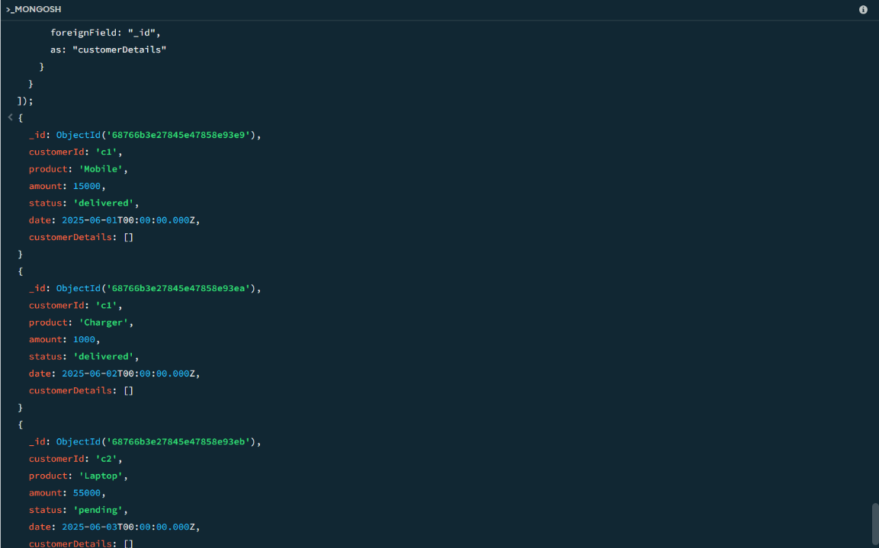

Project-192
Title:Demonstrate the use of `$out` in MongoDB aggregation
Source code:
db.orders.aggregate([ { $match: { status: "delivered" } }, { $out: "delivered_orders_backup" } ]);
Output:
